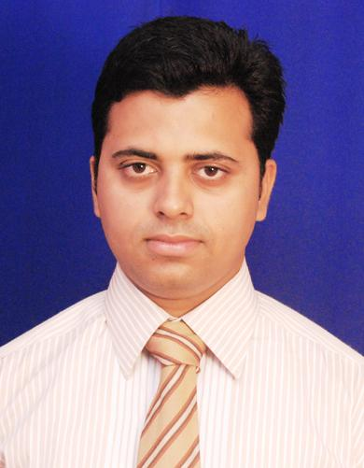
MAN MOHAN PANDA
Mobile: +91 – 8095455115
E-Mail: manmohanpanda84@gmail.com

“Onsite coordination manager, having 7+ years of management experience in Construction and Telecom.”

Executive Summary 
- A competent professional having over 7 years of exposure in Project Coordination, Planning, Operations, marketing and sales.
- Exposure in managing the sales, operations & maintenance of facilities and installation of new systems; for maximum service efficiency.
- Sound knowledge in troubleshooting & problem resolution and supervising the manpower in quality, adherence to work order specifications and equipment maintenance.
- Possess good team building, organisational and analytical skills coupled with demonstrated relationship management and communication abilities.

Areas of Expertise 
Quality Assurance: To ensure that all execution and inspection are carried out as per inspection plan, drawings & specifications. To carry out inspection & certify all necessary inspections during various stages of site activities as per approved inspection and test plan. Monitoring and surveillance on site to control the quality of work being implemented by the construction group.

Project Coordination: Handling project activities involving working out various requirements with respect to utilities, equipments, manpower & monitoring overall project operations for ensuring timely completion.

Operations: Planning the requirements and purchasing materials for various work related to construction and closely monitoring maintenance activities to ensure optimum usage patterns.

Sales & Marketing: Responsible for promotion, branding & marketing while managing sales of various real estate products of the company.

Documentation: Preparing sales & audit MIS

Employment Record 

Currently Working with Shanders Properties Pvt. Ltd at Bangalore, as “Onsite coordination manager”, from Nov 11 2010 to present.

Responsibilities
- Currently reporting at “SHANDERS DWELINGTON” a large Villa apartment project, at Electronic City, Bangalore.
- Handling set up teams which are being dedicated to Quality Assurance & Sales for the construction of residential projects.
- Inspecting the quality standard as specified by the Technical Director, through trained manpower.
- Managing profitability & responsible for revenue generation through channel sales partners & team.
- Leading projects as a key team member in QA department for all construction activities.
- Doing inspection activities for all construction works which are being related to the completion of the project.
- Handling project handover to customers as per the deadline set by Management.
- Daily reporting project work progress to CEO.

Achievements
- Successfully handed over “SHANDERS ALTA VISTA” a 196 flats villament project with all the amenities at electronic city, Bangalore. Which got the most environment friendly project of the year-2015 by ABP news in all over India.
- Successfully handed over “SHANDERS SPRINGDALE” A 96 flats villament which is at close proximity to ITPL, whitefield, Bangalore.
- Successfully handed over “SHANDERS VILLA GRANDE” a premium apartment which is at wanticouple, Mysore.

Worked with Amex Telecommunications as a Project Coordinator, from 1st April 2008 to 25th October 2010.

Responsibilities
- Managing the installation & integration of Huawei BTS (Idea, Reliance Projects), Ericson BTS (BSNL, Aircel Projects) and NEC microwave antennas.
- Supervising all technical works, coordinating the entire gamut of tasks ranging from acquiring new projects to billing of invoices.

Achievements
- Played a pivotal role in installing, integrating and commissioning of over 70 Huawei (3012 ΙΙ) BTS for Reliance Communication Ltd. in Karnataka, 172 Huawei (3900, 3900A, DBS) BTS for IDEA in Odisha, 95 Ericsson (2964, 2954, 3922) BTS for BSNL and AIRCEL in Odisha.
- Oversaw the Installation & Commissioning of NEC Paso link NEO IDU and ODU devices for IDEA, TATA and UNITEC in Odisha.
- Successfully handled the AT process in more than 60 sites for the Reliance GSM and 100 sites for IDEA and 95 sites for BSNL and AIRCEL.
- Worked on IBS set up of Reliance Project in Maharashtra.
- Managed the installation & commissioning of UBR Project of Reliance Communications at Mumbai.
- Successfully carried out the Ericson Project (BSNL, Aircle) in Orissa.
- Played a key role in handling the Huawei Project, Ericsson Project and NEC Project in Odisha/WestBengal/Gujrat/Karnataka since two years.

Academia 
- PGDBA (Marketing & Finance) from ICFAI National College (INC), Berhampur with CGPA 6.11 in 2008.
- B.E. (Electronics and Communication) from Sanjay Memorial Institute of Technology, Berhampur University with 70% marks in 2006.

IT Skills 

Operating Systems : Windows XP/VISTA/7.
Software : MS-Office 98/2003/2007 (Word, Excel & PowerPoint)

Personal Vitae 

Date of Birth : 20th May 1984
Present Address : Manmohan Panda, Nandi Retreat, B-209, survey no 92/2 & 92/3, kamanahalli village, begur hobli, south taluk, off bannerghatta road, Bangalore-560083.
Permanent Address: C/o- Sri Rabindra Panda, Bank Colony, Bapuji Nagar, 4th Lane, Berhampur
(Ganjam) – 760004, Odisha.
Languages Known : English, Hindi and Oriya.

